

Connite

Connite allows you to post/receive Homework, Announcements, and Chat with others in you class

Calendar

Your personal calendar to keep track of your tasks and events

Turning on auto add allows the calendar to automatically select a time slot for your test
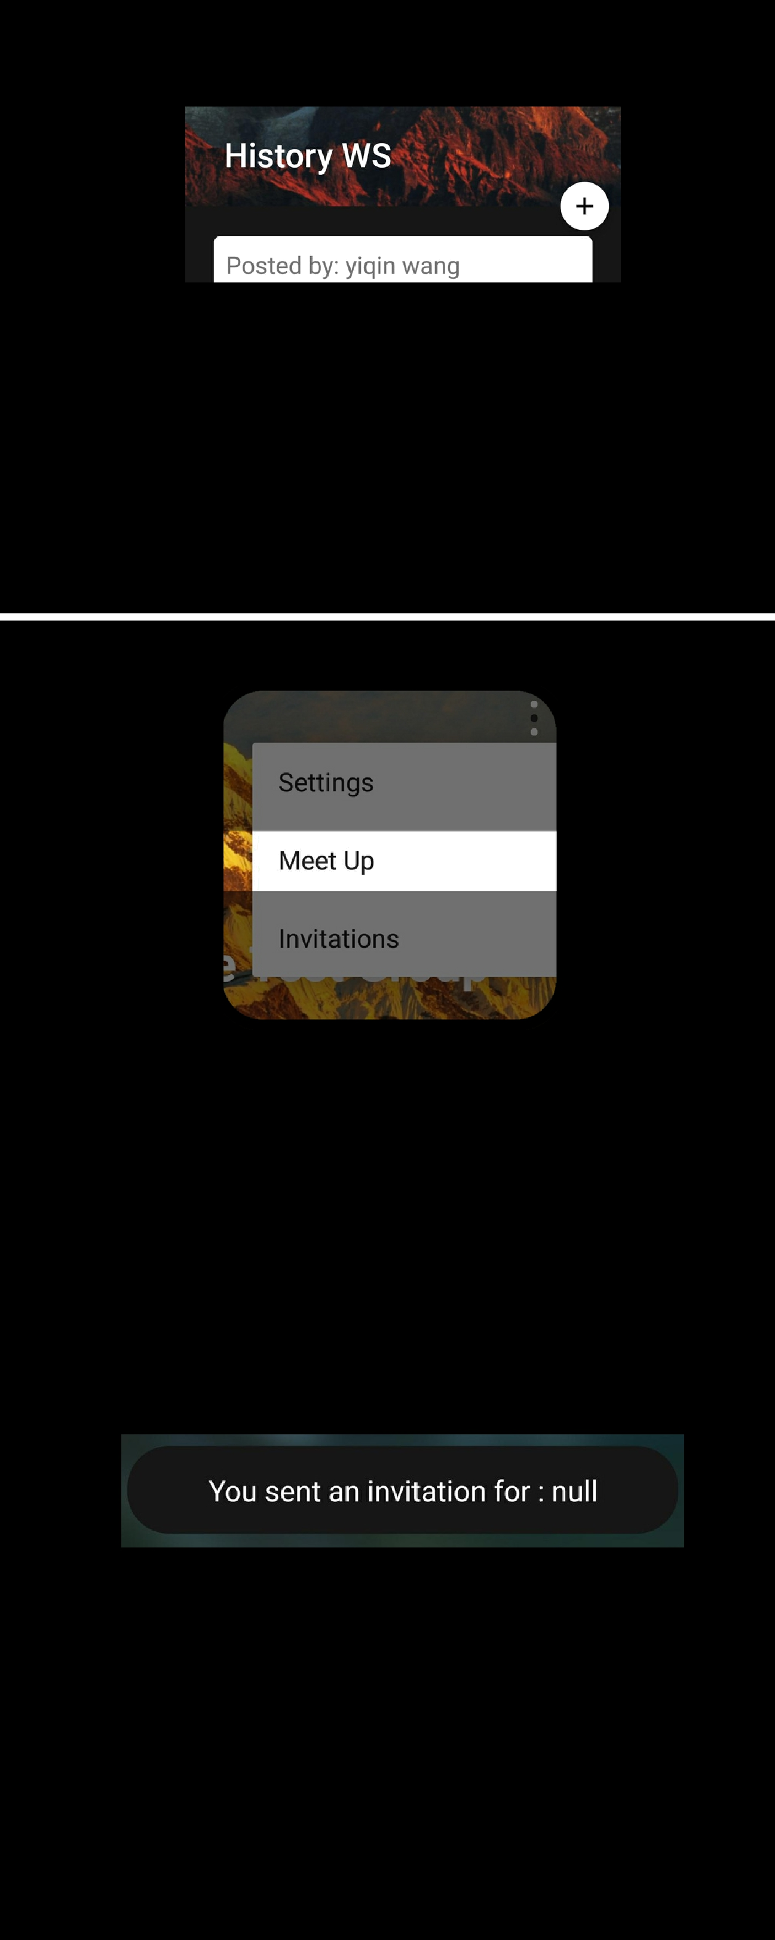

Clicking on the add button on the work/event details page allows you to add the task directly into your calendar

Use "Meet Up" to find a common free time slot within a group and schedule an outing or meeting with you friends

An invitation for the event would be sent to your friends via the chat

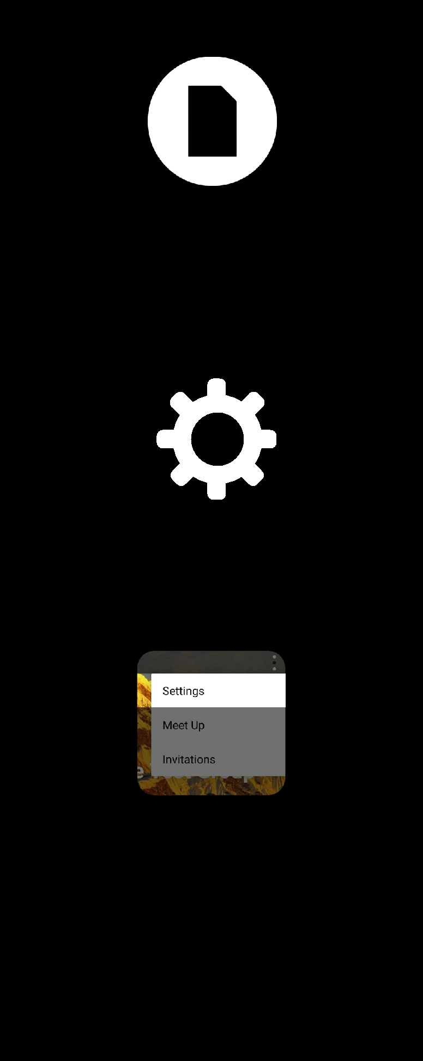

File Sharing allows you to share any type of files with members of you groups

Settings allows you to customise the app to your preferences

 When are you free?

Rest time between each task

When do you want to be reminded (notified) of you tasks?

